Section 5-1: Bisectors, Medians and Altitudes

SOL: None

Objectives:
Identify and use perpendicular bisectors and angle bisectors in triangles
Identify and use medians and altitudes in triangles

Vocabulary:
Concurrent lines – three or more lines that intersect at a common point
Point of concurrency – the intersection point of three or more lines
Perpendicular bisector – passes through the midpoint of the segment (triangle side) and is perpendicular to the segment
Circumcenter – the point of concurrency of the perpendicular bisectors of a triangle
Median – segment whose endpoints are a vertex of a triangle and the midpoint of the side opposite the vertex
Centroid – the point of concurrency for the medians of a triangle; point of balance for any triangle
Altitude – a segment from a vertex to the line containing the opposite side and perpendicular to the line containing that side
Orthocenter – intersection point of the altitudes of a triangle

Key Concept:

Perpendicular bisector properties:
A point is on the perpendicular bisector of a segment if, and only if, it is equidistant from the endpoints of the segment.
The three perpendicular bisectors of the sides of the triangle meet at a point, called the circumcenter of the triangle, which is equidistant from the three vertices of the triangle.

Angle bisector properties:
A point is on the angle bisector of an angle if and only if it is equidistant from the sides of the angle
The three angle bisectors of a triangle meet at a point, called the incenter of the triangle, which is equidistant from the three sides of the triangle.

Theorems:

Theorem 5.1: Any point on the perpendicular bisector of a segment is equidistant from the endpoints of the segment.

Theorem 5.2: Any point equidistant from the endpoints of the segments lies on the perpendicular bisector of a segment.

Theorem 5.3, Circumcenter Theorem: The circumcenter of a triangle is equidistant from the vertices of the triangle.

Theorem 5.4: Any point on the angle bisector is equidistant from the sides of the triangle.

Theorem 5.5: Any point equidistant from the sides of an angle lies on the angle bisector.

Theorem 5.6, Incenter Theorem: The incenter of a triangle is equidistant from each side of the triangle.

Theorem 5.7, Centroid Theorem: The centroid of a triangle is located two thirds of the distance from a vertex to the midpoint of the side opposite the vertex on a median.

Concept Summary:
Perpendicular bisectors, angle bisectors, medians and altitudes of a triangle are all special segments in triangles
Special Segments in Triangles
Name | Type | Point of Concurrency | Center Special  Quality | From  / To
Perpendicular  bisector | Line, segment or ray | Circumcenter | Equidistant  from vertices | None  midpoint of segment
Angle  bisector | Line, segment or ray | Incenter | Equidistant  from sides | Vertex  none
Median | segment | Centroid | Center of  Gravity | Vertex  midpoint of segment
Altitude | segment | Orthocenter | none | Vertex  none

Location of Point of Concurrency
Name | Point of Concurrency | Triangle Classification
Name | Point of Concurrency | Acute | Right | Obtuse
Perpendicular bisector | Circumcenter | Inside | hypotenuse | Outside
Angle bisector | Incenter | Inside | Inside | Inside
Median | Centroid | Inside | Inside | Inside
Altitude | Orthocenter | Inside | Vertex - 90 | Outside
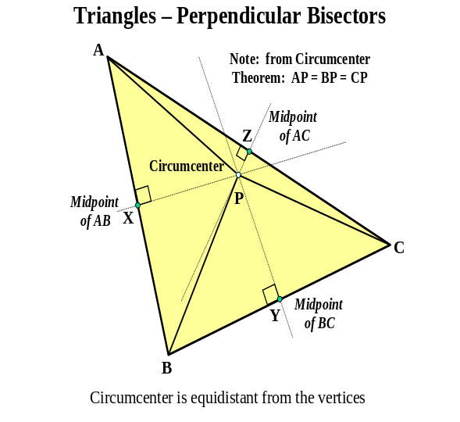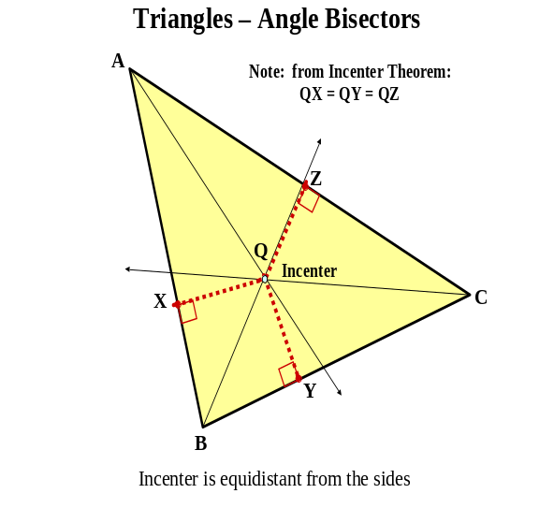Note the location of the point of concurrency changes depending on the angular classification of the triangle
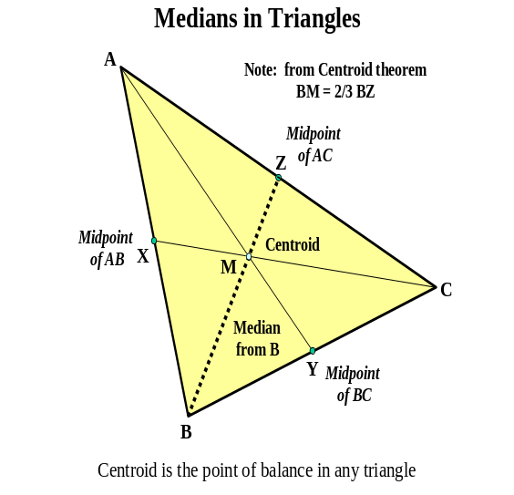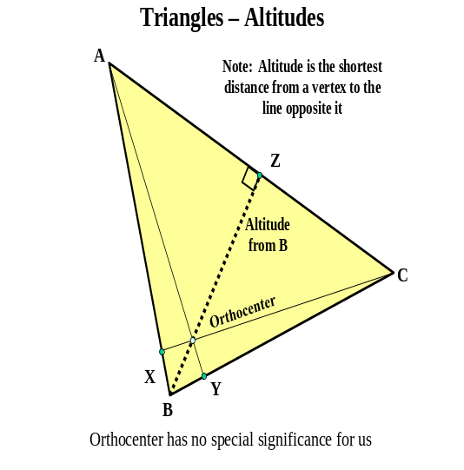

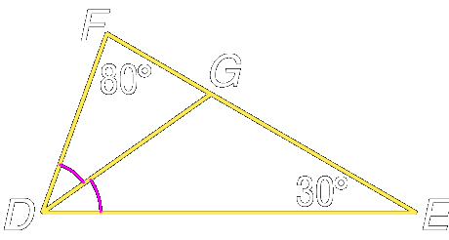
Example 1: Given m∠F = 80 and m∠E=30 and DG bisects ∠EDF,
find m∠DGE.

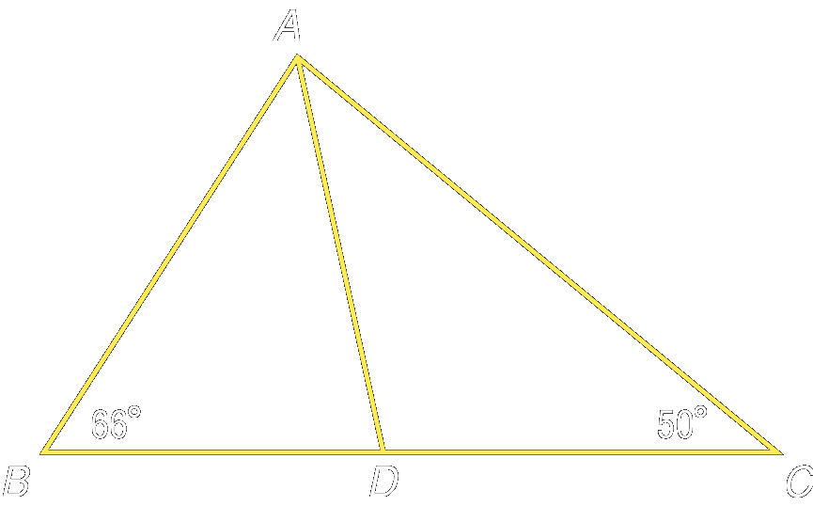

Example 2: Given m∠B = 66 and m∠C=50 and AD bisects ∠BAC,
find m∠ADC.

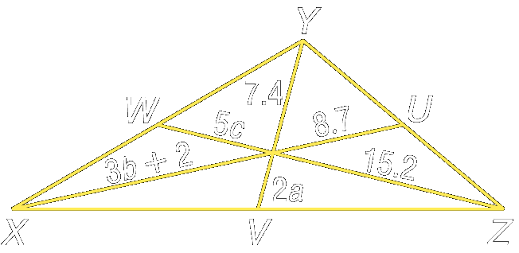
Example 3: Points U, V, and W are the midpoints of YZ, XZ and XY
respectively. Find a, b, and c.

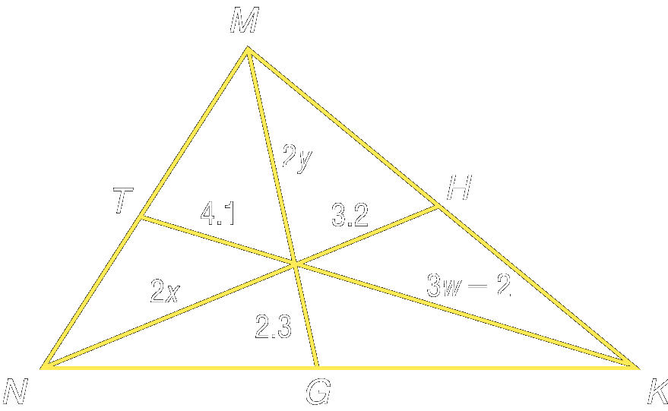
Example 4: Points T, H, and G are the midpoints of MN, MK, NK respectively. Find w, x, and y.

Reading Assignment:
Day 1: none Day 2: read section 5.2

Homework:
Day 1: pg 245: 46-49 Day 2: pg 245: 51-54
Section 5-2: Inequalities and Triangles

SOL: G.6 The student, given information concerning the lengths of sides and/or measures of angles, will apply the triangle inequality properties to determine whether a triangle exists and to order sides and angles. These concepts will be considered in the context of practical situations.

Objectives:
Recognize and apply properties of inequalities to the measures of angles of a triangle
Recognize and apply properties of inequalities to the relationships between angles and sides of a triangle

Vocabulary: No new vocabulary words or symbols

Key Concept: Definition of Inequality: For any real numbers a and b, a > b if and only if there is a positive number c such that a = b + c

Properties of Inequalities for Real Numbers
 | For all numbers a, b, and c
Comparison | a < b or a = b or a > b
Transitive | - If a < b and b < c, then a < c  - If a > b and b > c, then a > c
Addition and Subtraction | - If a < b, then a + c < b + c and a – c < b - c  - If a > b, then a + c > b + c and a – c > b - c
Multiplication and Division | - if c > 0 and a < b, then ac < bc and a/c < b/c  - if c > 0 and a > b, then ac > bc and a/c < b/c  - if c < 0 and a < b, then ac > bc and a/c > b/c  - if c < 0 and a > b, then ac < bc and a/c < b/c

Theorems:

Theorem 5.8, Exterior Angle Inequality Theorem: If an angle is an exterior angle of a triangle, then its measure is greater that the measure of either of it corresponding remote interior angles.
Theorem 5.9: If one side of a triangle is longer than another side, then the angle opposite the longer side has a greater measure than the angle opposite the shorter side.
Theorem 5.10: If one angle of a triangle has a greater measure than another angle, then the side opposite the greater angle is longer than the side opposite the lesser angle.

Concept Summary:
The largest angle in a triangle is opposite the longest side, and the smallest angle is opposite the shortest side.

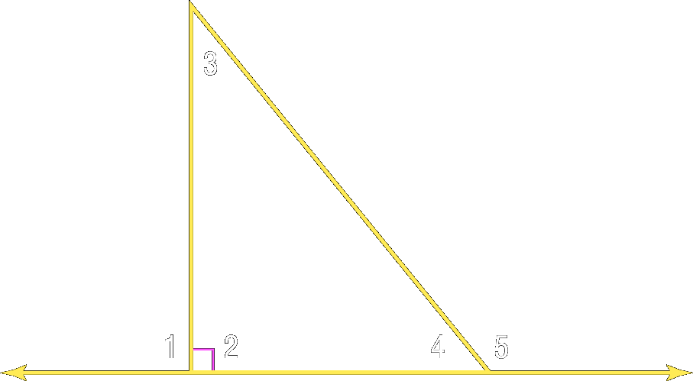
Example 1: Order the angles from greatest to least measure.

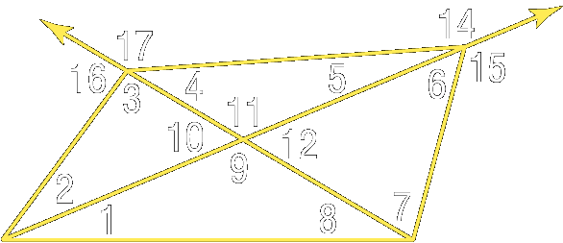
Example 2: Use the Exterior Angle Inequality Theorem to list all angles whose measures are less than m∠14.

Example 3: In the figure above, use the Exterior Angle Inequality Theorem to list all angles whose measures are greater than m∠5.

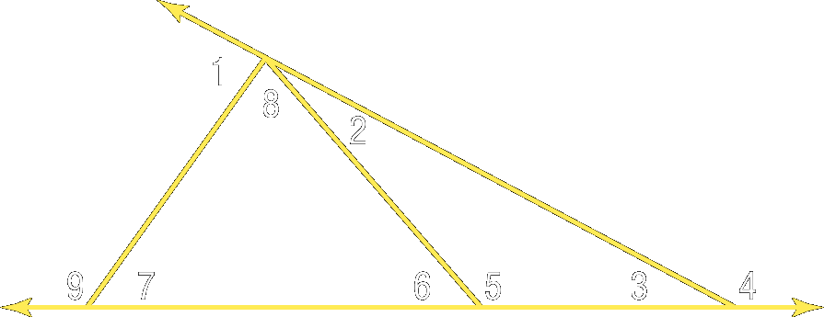
Example 4: Use the Exterior Angle Inequality Theorem to list all of the angles that satisfy the stated condition.

a. all angles whose measures are less than m∠4

b. all angles whose measures are greater than m∠8

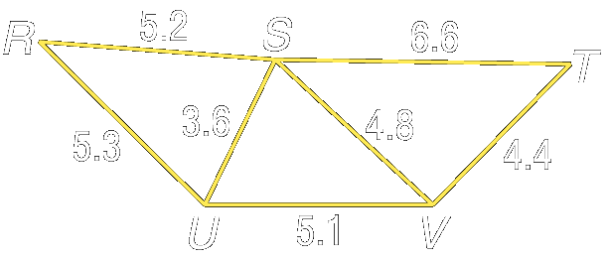
Example 5: Determine the relationship between the measures of the given angles.

a. ∠RSU and ∠SUR

b. ∠TSV and ∠STV

c. ∠RSV and ∠RUV

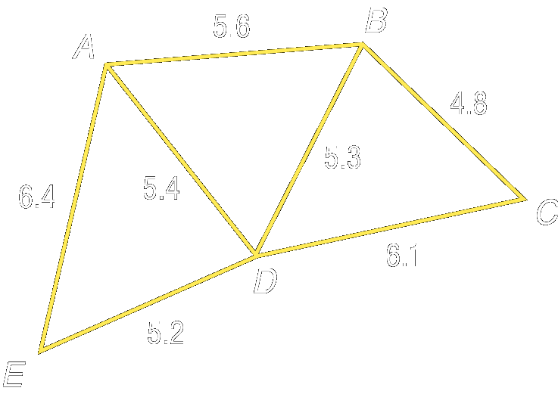
Example 6: Determine the relationship between the measures of the given angles.

a. ∠ABD, ∠DAB

b. ∠AED, ∠EAD

c. ∠EAB, ∠EDB

Reading Assignment: read section 5.3

Homework: pg 251: 4-15
Section 5-3: Indirect Proof

SOL: None

Objectives:
Use indirect proof with algebra
Use indirect proof with geometry

Vocabulary:
Indirect reasoning – showing something to be false so that the opposite must be true
Indirect proof – proving the opposite of what you assume is true
Proof by contradiction – proving the assumption contradicts some fact, definition or theorem

Key Concept:
- Assume that the conclusion is false
- Show that this assumption leads to a contradiction of the hypothesis, or some other fact, such as a definition, postulate, theorem or corollary
- Point out that because the false conclusion leads to an incorrect statement, the original conclusion must be true (the opposite of what we assumed in step 1)

Examples:

Algebraic Example:
Martha signed up for 3 classes at Wytheville Community College for a little under $156. There was an administrative fee of $15, but the class costs varied. How can you show that at least one class cost less than $47?
Given: Martha spent less than $156
Prove: At least one class cost (x) less than $47
Step 1: Assume x ≥ $47
Step 2: Then $47 + $47 + $47 + $15 ≥ $156
Step 3: This contradicts what Martha paid, so the assumption must be false.
Therefore one class must cost less than $47!

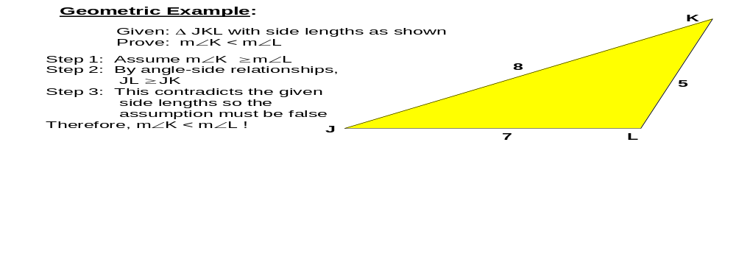

Concept Summary:
In an indirect proof, the conclusion is assumed to be false and a contradiction is reached.

Example 1:
- State the assumption you would make to start an indirect proof for the statement
EF is not a perpendicular bisector.

- State the assumption you would make to start an indirect proof for the statement
3x = 4y + 1

- State the assumption you would make to start an indirect proof for the statement
m∠1 is less than or equal to m∠2.

- State the assumption you would make to start an indirect proof for the statement
If B is the midpoint of LH and LH = 26 then BH is congruent to LH.

Example 2: State the assumption you would make to start an indirect proof for the statement
- AB is not an altitude

- a = ½ b – 4

- m∠ABC is greater than or equal to m∠XYZ

- If LH is an angle bisector of ∠MLP, then ∠MLH is congruent to ∠PLH

Example 3: Write an indirect proof to show:
1
Given: ----------- = 20
2y + 4
Prove: y ≠ -2

Example 4: Write an indirect proof to show:
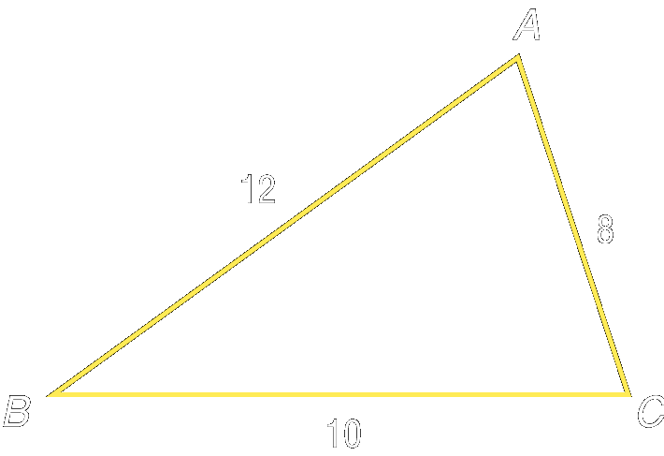
Given ΔABC with side lengths 8, 10, and 12 as shown
Prove: m∠C > m∠A

Reading Assignment: read section 5.4

Homework: pg 258-9: 4-6, 13, 14 Proofs: 11, 22
Section 5-4: The Triangle Inequality

SOL: G.6 The student, given information concerning the lengths of sides and/or measures of angles, will apply the triangle inequality properties to determine whether a triangle exists and to order sides and angles. These concepts will be considered in the context of practical situations.

Objectives:
Apply the Triangle Inequality Theorem
Determine the shortest distance between a point and a line

Vocabulary: No new vocabulary words or symbols.

Theorems:

Theorem 5.11, Triangle Inequality Theorem: The sum of the lengths of any two sides of a triangle is greater than the length of the third side.

Theorem 5.12: The perpendicular segment from a point to a line is the shortest segment from the point to the line.

Corollary 5.1: The perpendicular segment from a point to a plane is the shortest segment from the point to the plane.

Concept Summary:
The sum of the lengths of any two sides of a triangle is greater then the length of the third side

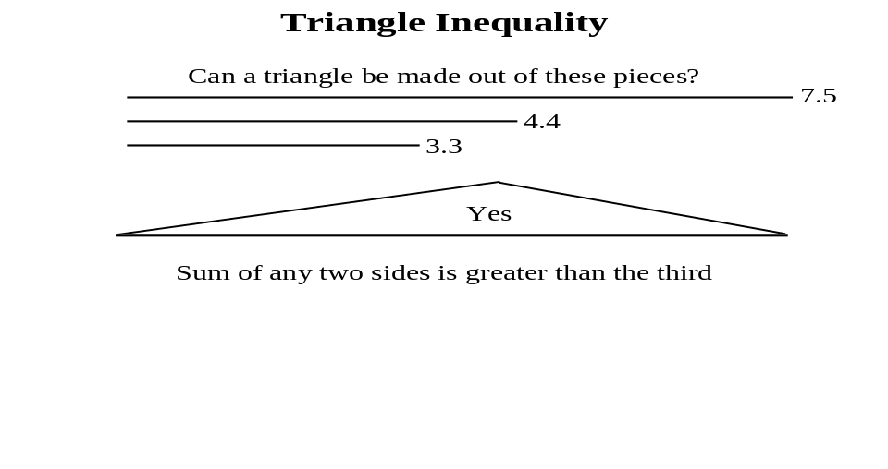

Example 1: Determine whether the measures 6½, 6½, and 14½ can be lengths of the sides of a triangle.

Example 2: Determine whether the measures 6.8, 7.2, and 5.1 can be lengths of the sides of a triangle.

Example 3: Determine whether the given measures can be lengths of the sides of a triangle.
- 6, 9, 16

- 14, 16, 27

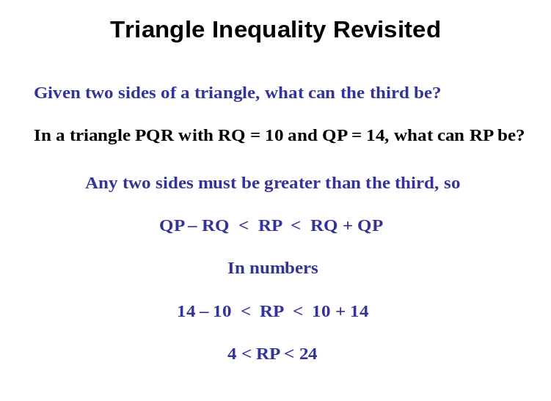

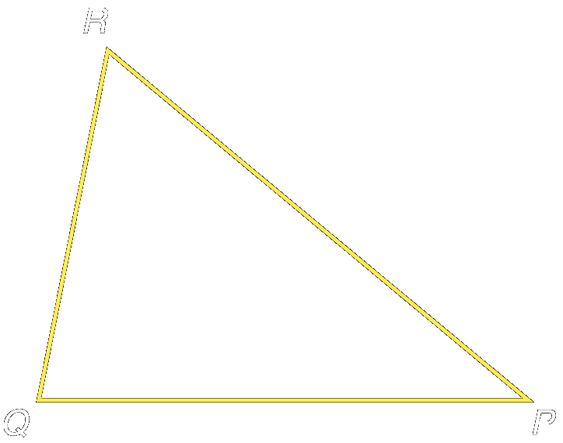
Example 4: In ∆PQR, PQ = 7.2 and QR = 5.2,
which measure cannot be PR?

A 7 B 9 C 11 D 13

Example 5: In ∆XYZ, XY = 6 and YZ = 9,
which measure cannot be XZ?

A 3 B 9 C 12 D 14

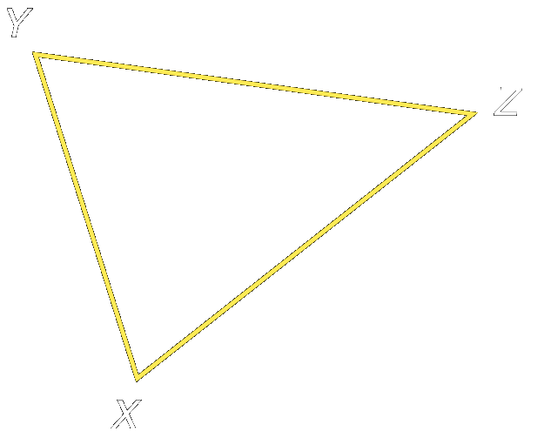

Reading Assignment: read section 5.5

Homework: pg 264: 15-19, 27-31
Section 5-5: Inequalities Involving Two Triangles

SOL: None.

Objectives:
Apply the SAS Inequality
Apply the SSS Inequality

Vocabulary:
Included side – the side in common between two angles (the end points are the vertexes)
Included angle – the angle formed by two sides sharing a common end point (or vertex)

Theorems:

Theorem 5.13: SAS Inequality or Hinge Theorem: If two sides of a triangle are congruent to two sides of another triangle and the included angle in one triangle has a greater measure than the included angle in the other, then the third side of the first triangle is longer that the third side of the second triangle.

Theorem 5.14: SSS Inequality: If two sides of a triangle are congruent to two sides of another triangle and the third side in one triangle is longer than the third side in the other, then the angle between the pair of congruent sides in the first triangle is greater than the corresponding angle in the second triangle.

Concept Summary:
SAS Inequality: In two triangles, if two sides are congruent, then the measure of the included angle determines which triangle has the longer third side.
SSS Inequality: In two triangles, if two sides are congruent, then the length of the third side determines which triangle has the included angle with the greatest measure.

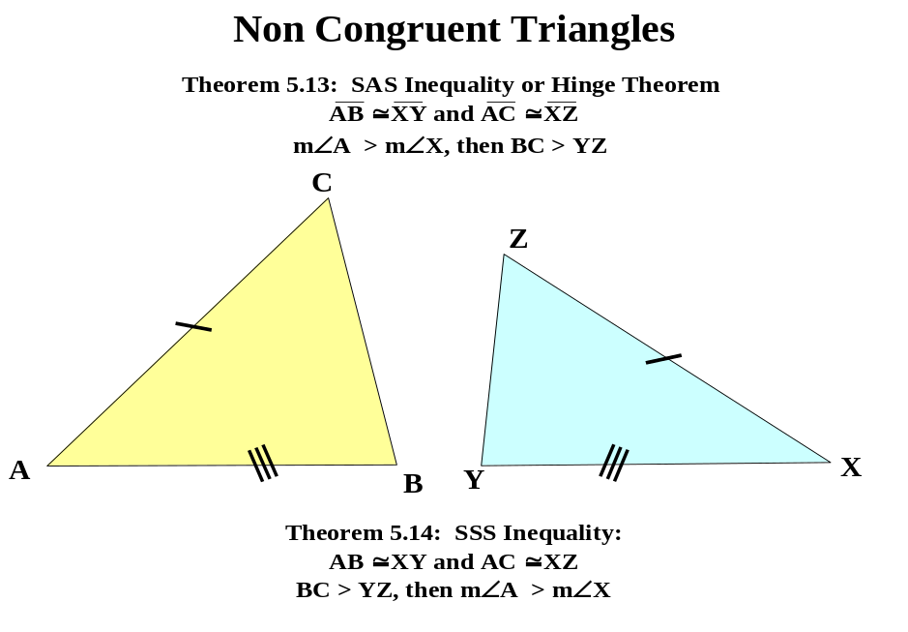

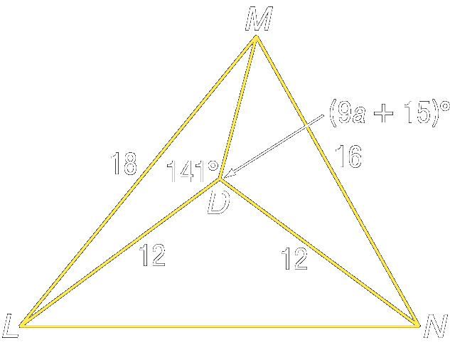
Example 1: Write an inequality comparing m∠LDM and m∠MDN
using the information in the figure.

Example 2: Write an inequality finding the range of values
containing a using the information in the figure.

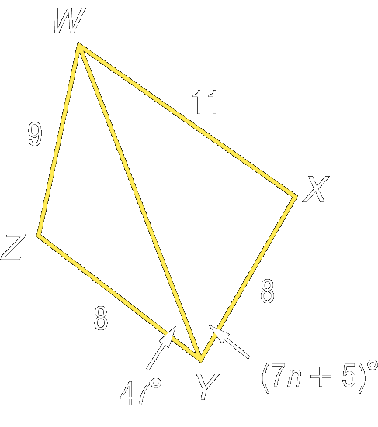
Example 3: Write an inequality using the information in the figure.

- Compare m∠WYX and m∠ZYW

- Find the range of values containing n.

Example 4: Doctors use a straight-leg-raising test to determine the amount of pain felt in a person’s back. The patient lies flat on the examining table, and the doctor raises each leg until the patient experiences pain in the back area.

- Nitan can tolerate the doctor raising his right leg 35° and his left leg 65° from the table. Which foot can Nitan raise higher above the table?

- Megan can lift her right foot 18 inches from the table and her left foot 13 inches from the table. Which leg makes the greater angle with the table?

Reading Assignment: read over Chapter 5

Homework: pg 270 – 273: 3-6, 13-16, 32
5 Minute Reviews:
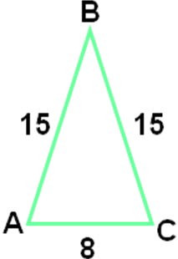
5-1: Refer to the figure.
1. Classify the triangle as scalene, isosceles, or equilateral.

2. Find x if m∠A = 10x + 15, m∠B = 8x – 18, and m∠C = 12x + 3.

3. Name the corresponding congruent angles if ΔRST ≅ ΔUVW.

4. Name the corresponding congruent sides if ΔLMN ≅ ΔOPQ.

5. Find y if ΔDEF is an equilateral triangle and m∠F = 8y + 4.

6. What is the slope of a line that contains (–2, 5) and (1, 3)?
a. -2/3 b. 2/3 c. -3/2 d. 3/2

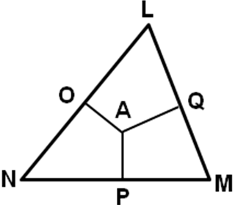
5-2: In the figure, A is the circumcenter of ΔLMN.
1. Find y if LO = 8y + 9 and ON = 12y – 11.

2. Find x if m∠APM = 7x + 13.

3. Find r if AN = 4r – 8 and AM = 3(2r – 11).

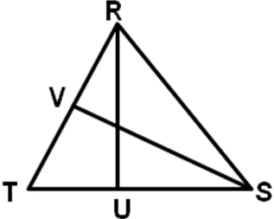
In ΔRST, RU is an altitude and SV is a median.
4. Find y if m∠RUS = 7y + 27.

5. Find RV if RV = 6a + 3 and RT = 10a + 14.

6. Which congruence statement is true if P is the circumcenter of ΔWXY?
a. WX ≅ XY b. WP ≅ XP c. WP ≅ WX d. WY ≅ XY

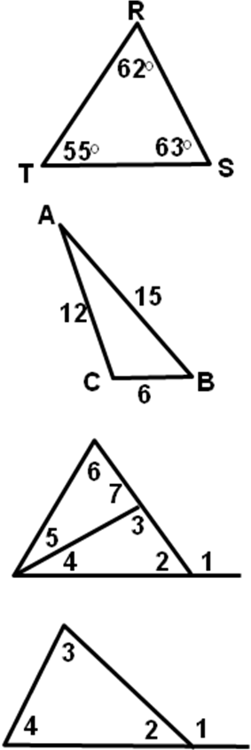
5-3: Determine the relationship between the lengths of the given sides.
1. RS, ST

2. RT, ST

Determine the relationship between the measures of the given angles.
3. ∠A, ∠B

4. ∠B, ∠C

Refer to the figure.
5. Use the Exterior Angle Inequality Theorem to list all angles whose measures are less than m∠1.

6. Which angle has the greatest measure?
a. ∠1 b. ∠2 c. ∠3 d. ∠4

5-4: Write the assumption you would make to start an indirect proof of each statement.
1. ΔABC ≅ ΔDEF

2. RS is an angle bisector.

3. ∠X is a right angle.

4. If 4x – 3 ≤ 9, then x ≤ 3.

5. ΔMNO is an equilateral triangle.

6. Which statement is a contradiction to the statement that ∠W and ∠V are vertical angles?
a. ∠W ≅ ∠V b. m∠W = 85° c. m∠W > m∠V d. ∠W is acute

5-5: Determine whether the given measures can be the lengths of the sides of a triangle. Write yes or no.
1. 5, 7, 8

2. 4.2, 4.2, 8.4

3. 3, 6, 10

Find the range for the measure of the third side of a triangle given the measures of two sides.
4. 4 and 13

5. 8.3 and 15.6

6. Which cannot be the measure of the third side of a triangle if two sides measure 8 and 17?
a. 15 b. 19 c. 22 d. 26

